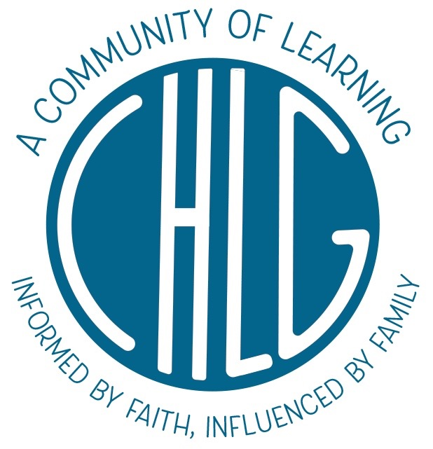

2021-22 Middle School Membership Agreement

Family and Child(ren)’s Name(s):__________________________________________________________

Parent E-mail Address:__________________________________________________________________

1. I understand that by submitting a deposit (1/5th of the total tuition) with my application, that I am committing to the acceptance of any 2021-22 placement subsequently awarded by CHLG, and that this acceptance includes a commitment to paying the full annual tuition. If my child is placed, I will pay the remaining tuition according to the schedule outlined under #3 below. I understand that a future withdrawal from CHLG may not free me from this tuition obligation, and that additional information about this is outlined in #s 4, 5 and 6 below. CHLG will return my deposit if unable to offer a placement.

2. I understand that my child will not be allowed to attend CHLG until I have submitted the appropriate health and enrollment forms (including health forms and background checks for adults who will be volunteering onsite). Additionally, I understand that my child’s start date may be affected if health or enrollment forms are submitted after the August 1, 2021 due date.

3. I agree to the following annual tuition fees for the 2021-22 school year: $7,600 annually ($760 per month) for middle school students (5th-8th). I understand that the remaining tuition (after the 1/5th deposit) will be divided into eight equal payments, each due on the first of the month beginning June 1, 2021 and ending January 1, 2022. I will register for tuition payments using the Tuition Management system as directed by CHLG. CHLG will assess a $30 fee for each failure to collect a payment. If I fail to register for tuition payments or otherwise disrupt payment of my tuition without notifying CHLG’s Treasurer (Sara Beth Arcara) regarding any issues surrounding tuition payment, my child’s placement may be given to a child on the waitlist, in which case I will forfeit my deposit and any tuition payments that have been made in accordance with the tuition schedule listed above.

4. I understand that if I withdraw my child for any reason other than those outlined in #5 below, that I am responsible for paying the full annual tuition (according to the monthly payment schedule listed under #3) until CHLG is able to enroll an appropriate student into the classroom that my child vacated. I agree to continue making all remaining tuition payments until I am informed by CHLG that my child's vacated placement has been filled.

5. I understand that there are monetary penalties for a withdrawal from CHLG, and that the penalties differ depending on the reason for withdrawal. If I withdraw my child according to one of the three scenarios listed below, I understand that I will forfeit my deposit and any additional tuition that has been paid up to the point of notification, and that I must pay appropriate tuition for 30 days forward from the date of notification (tuition will be prorated if applicable). The three scenarios are:

- an out of area move (greater than 20 miles from the school address)
- a medical hardship on the part of the parent/guardian or the student (as confirmed by a practicing physician and approved by the Head of School) or
- a disciplinary dismissal by CHLG

6. Should I need to withdraw my child from CHLG, I understand that the withdrawal date cannot be set less than 30 days from the time I notify CHLG. Withdrawal notification must be made in writing to both Martha Herndon, Head of School, and Sara Beth Arcara, Director of Admissions and Membership, Treasurer. Confirmation of receipt of such notification will be a written response from a CHLG administrator within two business days confirming the withdrawal date.

7. I understand that it is my responsibility to be aware of my state's homeschool requirements, including annual registration as a homeschooler, and to maintain all records as required by the state. I also understand that it is my responsibility to work with my child at home to ensure that he or she completes the coursework and projects as assigned by CHLG teachers.

8. I understand that the first several weeks of school are very important to my child's integration into a new grade level as well as my introduction to new curriculum and routines for the home-based portion of CHLG’s program. As such, our family will avoid out-of-town travel during the first several weeks of September (where possible). I also understand that a timely arrival to school each morning (9:00) is very important, as this aids teachers in facilitating daily lessons.

9. I will make it a priority to attend the parent orientation sessions prior to the start of school. I also understand that there are specific expectations for the parent who facilitates the majority of the home-based organization and instructional support, including viewing pre-recorded curriculum videos prior to the start of school, and attendance at the Curriculum Workshop which is held during the first week of school (the curriculum workshop includes presentations by CHLG staff and is mandatory for the parent/guardian who facilitates the majority of the home-based organization and instructional support).

10. I understand that parents and guardians of middle school students are responsible to complete 25 volunteer hours (annually) for the first child involved and five additional hours for each subsequent child. I am aware that a portion of these hours consists of morning and afternoon duties I schedule in the school calendar (these include photocopying and general teacher assistance and afternoon cleanup). I also understand that our family will be responsible for completing one of four Saturday work days during the school year as part of our volunteer responsibility. I understand that additional volunteer hours will be served through other projects as offered and approved by the school, and that I will be charged $30 for each volunteer hour our family lacks at the end of the school year.

11. I will maintain membership in CHLG’s school management system, Class Reach. I understand that administrators and teachers use Class Reach to communicate important information regarding scheduling, class content, assignments, grading and upcoming events, and I will therefore be diligent in regularly reading postings and responding as necessary.

This document only intends to define the agreement between the signing parent and Capitol Hill Learning Group, LLC. Capitol Hill Learning Group and its members are not liable for accidental injuries or incidents occurring at the church or school, on the church or school grounds, or during excursions.

Signature:_________________________________________________ Date:______________________

Print Name:___________________________________________________________________________

Please keep a copy of this document for your personal records.

